CIS 463 Project
Financial Analysis Application

In this assignment you will create a financial application in Business Intelligence Studio. When you are completed with this project, you will have a cube that can display

Relevant Tables for the Data Source View

The tables from the AdventureWorksDW database that you will need to include the following: DimAccount, DimCurrency, DimDepartmentGroup, DimOrganization, DimScenario, DimTime and FactFinance.

However, you do not want ALL accounts from the DimAccount table. Note that some accounts are currency accounts and others are units accounts, You can see this if you open the DimAccount table and view all its data. The column that contains either "Currency" or Units" will be the relevant field for you to look at when you create a named query for your account data instead of the full DimAccount table; all you will want are the currency accounts.

The other thing to consider is that not all the rows from the FactFinance table are associated with currency accounts. There is a one-to-many relationship between DimAccount and FactFinance, and the only rows you will want from the FactFinance table are those that are currency-oriented. So, you will also want a named query instead of the full FactFinance table, and there should be a one-to-many relationship between the CurrencyAccounts named query and the FinanceFromCurrencyAccounts named query. When you are finished with your Data Source View, it will look something like this:

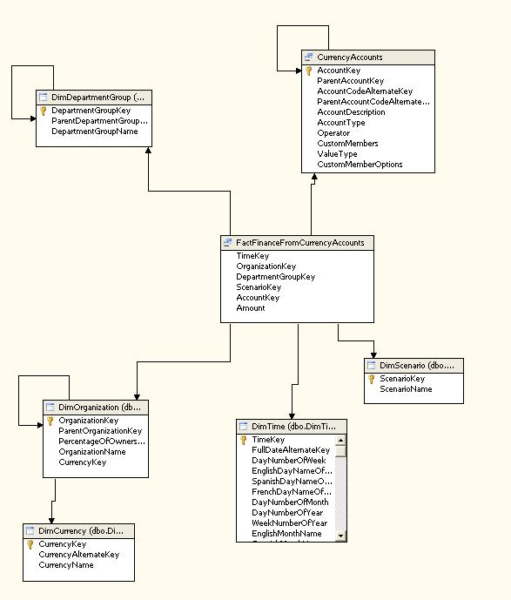

Creating Dimensions

Once you've set up your Data Source View, you are ready to create some dimensions. Make a dimension for each of the following Dimension tables and named set: Department, Organization, Scenario, Time, and CurrencyAccount. The first three dimensions need nothing special, but there are certain specifications required for the Time and CurrencyAccount dimensions:

For the Time Dimension

All we are concerned with here is calendar time. And we are only concerned with calendar years, calendar quarters and months. So when creating a dimension from the DimTime table, call it Financial Time Frame, and only include the necessary attributes. Note, you are going to want to make a hierarchy for this, so that when browsing you would see the following (note: remember how you made proper text appear and how you made months and quarters and years appear in the proper order. Go back to lessons 3 and 4 if you need).

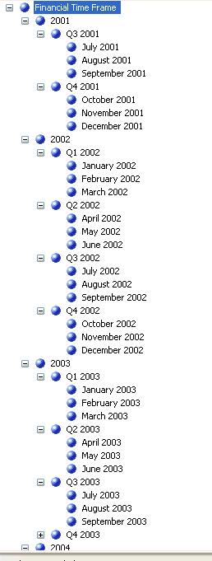

For the CurrencyAccount Dimension

This dimension should make all accounts ordered by the account description in the browser. Also, there should be a user-defined hierarchy in which accounts are organized by Account Type. This hierarchy would look like this in the dimension's browser:

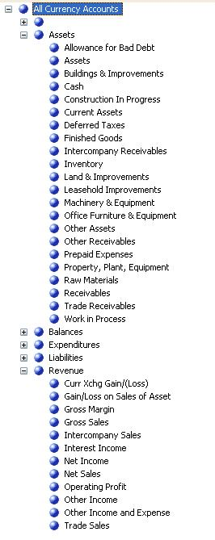

The Cube

If you got to this point correctly, then you should be able to browse the cube. There is really only one measure of interest; this is the Amount from the Finance fact table (measure group). For example, if you browsed the cube by the Account Type hierarchy, you should see something like this:

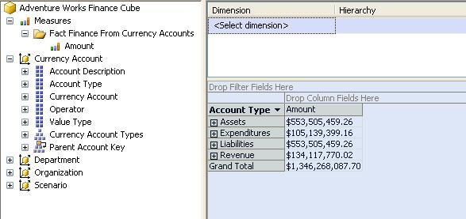

Getting the Cube to Accurately Add Assets/Revenue and Subtract Liabilities/Expenditures

This is a good start, but it really isn't accurate. What the Calculate command is doing is adding up all the accounts to produce a sum. But in reality, some amounts should be positive and others should be negative. Assets and Revenue are positive numbers, indicating inflow of cash or goods. Expenditures and Liabilities, on the other hand, should be negative. So, rather than summing all numbers, the calculation should subtract the liabilities and expenditures.

To accomplish this, you can create a SCOPE statement (using MDX script in the cube's Calculate tab) to specify the subcube consisting of expenditures and liabilities, and then change its Amount values to negative numbers. In lesson 6 you learned how to create SCOPE.

When using a SCOPE statement, you are specifying a subcube of the overall cube that be affected by the statements embedded in the SCOPE. This subcube is specified as some combination of dimension members and/or measures separated by commas.

For example, consider this SCOPE statement from Lesson 6 of the SSAS tutorial:

SCOPE ([Measures].[Sales Amount Quota],[Date].[Fiscal Date].[Fiscal Year].&[2005], [Employee].[Employees].Members);

This statement specifies a subcube that consisting one measure and two dimensions (as illustrated by the three separate colors). The only measure (fact) of concern for this subcube is [Sales Amount Quota]. The dimensions that bracket this subcube are Employee and Date. Within the Employee dimension, only the members (distinct values) of the [Employees] hierarchy are included in this subcube. Within the [Date] dimension there is an even greater restriction in that only the 2005 member of the Fiscal Year attribute (within the Fiscal Date hierarchy) is included in the subcube; all other members and attributes of the Date dimension are not included in the specified subcube. Your list of measures and/or dimension member sets can be as long as you like; in the above example there are three of them.

After you have specified a subcube, the THIS keyword refers to that particular subcube, instead of the cube as a whole. For the above scope, THIS refers to any cell in the multidimensional space that is a Sales Amount Quota measure narrowed in on 2005 as the fiscal year and applied to all members of all attributes within the Employees hierarchy. You can use assignment operator for assigning values into THIS, such as for example assigning an expression that includes a particular measure.

THIS will continue to refer to only the cells of the SCOPE statement until the script reaches the END SCOPE statement (at which point it again refers to the whole cube) or another SCOPE statement (at which point it refers to cells within that new subcube).

In a way, you can think of the subcube specified in the SCOPE statement as a “programmed” version of a pivot table, or to put it another way, as dynamically “slicing and dicing” the cube so that you can apply subsequent statements to only the “sliced/diced” portions.

With this in mind, for the Financial Analysis problem one easy way to accomplish your task is to create two separate subcubes (using two different SCOPE statements), one for the Expenditures member of the Currency Account dimension’s Account Type attribute, and the other for the Liabilities member of the same attribute. Then, you can use THIS for assigning the appropriate value for the cells in the specified subcube, based on negating the Amount measure. In other words, you can do an assignment statement, similar to what was done in Lesson 6 of the tutorial.

If you create a calculation script correctly to accomplish this, you will enable the browser to look like this:

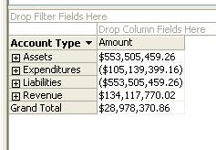

Note that the expenditures and liabilities are now shown as negative values (in parentheses) and the grand total is a much smaller number than it was before. Take care to ensure that the subcategories are also correctly showing positive or negative numbers:

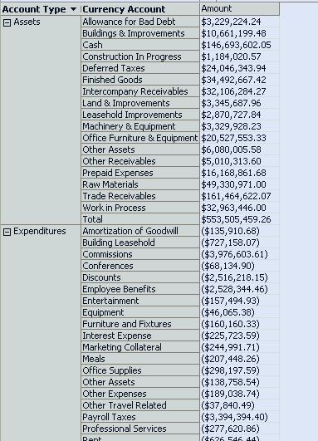

To make the effect more dramatic, see if you can get the expenditures and liabilities to show up in red (using the FORE_COLOR cell property function), like this:

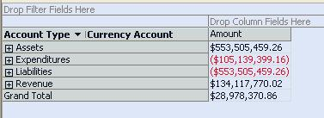

Within a cube, the syntax for this would be:

FORE_COLOR(THIS)=255;

Adding Time to browser columns comes out like this:

